TOTHBOT
KRAKEN SYSTEM ARCHITECTURE OVERVIEW
The Complete System — All Architectural Decisions + All Flow Diagrams

DocDCN: | 0500000
DocTitle: | TothBot_Kraken_System_Architecture_Overview
DocVersion: | dv1_4
DocOwner: | Bill
DocPath: | GitHub.com/TothBot/TothBot-V2-Docs/05XXXXX_System_Architecture/0500000_System_Architecture_Overview_dv1_4.docx
DocDate: | 03-24-2026
DocTime: | 23:59:59 UTC

PURPOSE: This document captures all architectural decisions, FP/DP analyses, and system specifications from the TothBot Kraken architecture sessions of March 2026. Includes all six system flow diagrams showing connections between Kraken, TothBot, and CIATS as one unified organism.

Diagrams in this document (dv1_4 — all updated):
Diagram 1 — Kraken API Connection Architecture (dv1_4: cl_ord_id, stp_type, reconnect distinction, MPP note, DMS/FIX rejection documented)
Diagram 2 — TothBot Trading Pipeline (dv1_4: cl_ord_id + stp_type on add_order)
Diagram 3 — Exit Architecture: Ground Zero Redesign (dv1_4: MPP risk L2+L3, OTO evaluated and rejected)
Diagram 4 — Regime Taxonomy: 6-Regime Grid + Two-Level Tagging
Diagram 5 — CIATS Architecture: Data Flows and Improvement Cycle
Diagram 6 — Complete System: One CIATS-Owned Organism (dv1_4: cl_ord_id registry, stp_type, MPP handling)

1. System Identity and Mission

1.1 What TothBot Is
TothBot is an automated cryptocurrency spot trading system on Kraken exchange. It runs 24/7/365 on a Hetzner VPS, processes 5-minute OHLC candle close events as its system clock, and executes long-only trades using a momentum-based signal engine.
TothBot is not an external system connected to Kraken — it IS Kraken’s event processor. Every action is a response to a Kraken push event. No timers. No polling. Idle and silent until Kraken speaks.

1.2 The One Organism Principle
Three functional zones, one organism:
· Kraken: generates events, executes orders, holds resting TP limit orders and off-book emergency SL stop orders on matching engine
· TothBot: processes Kraken events, executes trading strategy, manages positions
· CIATS: learns from event records, continuously improves processing rules

PRIMARY MISSION: Maximize profit. Minimize loss. With an emphasis on minimizing loss. Loss prevention takes priority over profit generation. Everything else is secondary.

1.3 Operating Environment
Parameter | Value
Exchange | Kraken Spot (Long Module — Short deferred)
Language | Python 3.12.3
VPS | Hetzner CPX22 — 87.99.141.44 — Ashburn VA (Kraken Spot servers: AWS us-west-2 Oregon)
System Clock | Kraken OHLC 5-minute candle close event (WS v2 push)
Fee Baseline | Maker 0.16% / Taker 0.26% (CIATS monitors actuals)
Operation | 24/7/365 — CIATS may add stand-down periods via PDCA if data supports
Starting Portfolio | $1,000 Long Module
Sacred constraint | Net 1:1.5 R:R — hardcoded — the only number not owned by CIATS

2. Kraken API Connection Architecture
All connection points verified across three independent analysis passes (15 total sources) plus second deep validation (10 searches, 77+ sources). The diagram below shows the complete interface between TothBot and Kraken with all data flows.

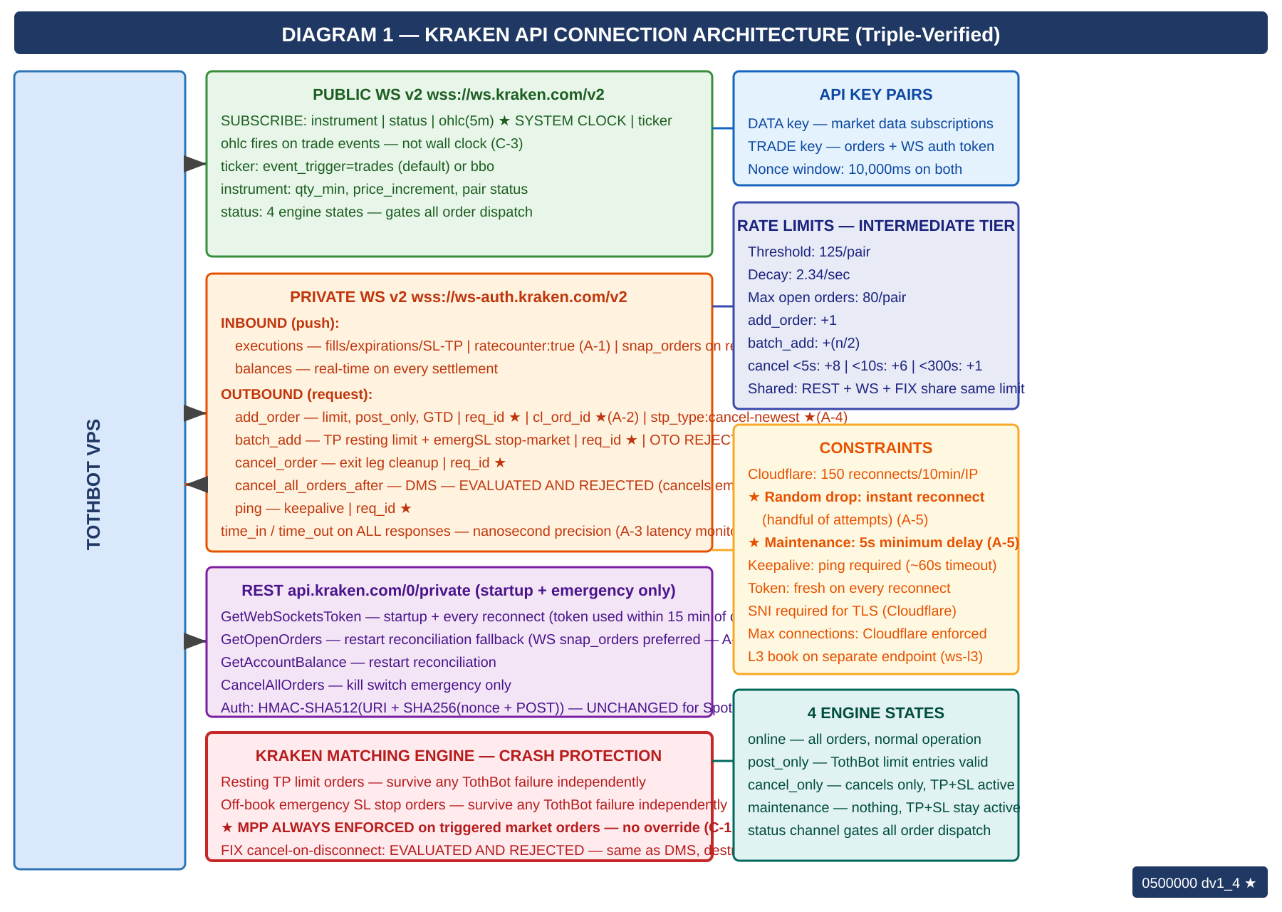

2.1 Key Connection Points
· Public WS v2: instrument (asset specs) · status (engine state) · ohlc-5m (system clock) · ticker (price data, event_trigger configurable)
· Private WS v2 inbound: executions (fills/expirations/SL-TP triggers, ratecounter:true enabled — A-1, snap_orders:true on reconnect — A-3) · balances (real-time settlement)
· Private WS v2 outbound: add_order (entry) · batch_add (SL+TP atomic) · cancel_order (exit leg cleanup) — all messages carry req_id (A-2), cl_ord_id assigned by TothBot (A-2), stp_type:cancel-newest (A-4)
· REST: only GetWebSocketsToken (startup/reconnect) · GetOpenOrders + GetAccountBalance (restart reconcile fallback — WS snap_orders preferred per A-3) · CancelAllOrders (kill switch emergency)
· Matching Engine: resting TP limit orders and off-book emergency SL stop orders survive any TothBot failure independently — crash protection
· cancel_all_orders_after (WS v2 DMS): EVALUATED AND REJECTED — would cancel emergSL crash protection on TothBot failure (see AR-001)
· FIX API cancel-on-disconnect: EVALUATED AND REJECTED — same architectural conflict, destroys crash protection (see AR-001)

2.2 Four Kraken Engine States
State | TothBot Behavior
online | All orders. Signal pipeline runs normally.
post_only | TothBot limit+post_only entries ARE valid. Trading continues.
cancel_only | No new entries. Exit Controller can cancel. Resting TP and off-book SL stop orders active.
maintenance | No orders, no cancels, no matching. Resting TP and off-book SL stop orders active on engine.

2.3 API Rate Limits — Intermediate Tier (C-2)
Rate limits are shared across REST, WebSockets, and FIX — there is no separate per-protocol budget.

Parameter | Intermediate Tier Value
Rate counter threshold (per pair) | 125
Rate counter decay (per second) | 2.34
Max open orders (per pair) | 80
Add order fixed cost | +1
Batch add fixed cost | +(n/2) where n = orders in batch
Cancel order cost (< 5s old) | +8
Cancel order cost (< 10s old) | +6
Cancel order cost (< 300s old) | +1

Operational note: At Layer 2 MAE exit, the Exit Controller cancels both TP and emergSL before market-selling. Cancel cost depends on how long those orders have been resting. The 125 threshold per pair with 2.34/sec decay provides substantial headroom at TothBot’s 5-minute candle frequency. Full rate limit specification and CIATS monitoring hooks documented in 0411003.

2.4 WS Operational Requirements (A-1 through A-5)
A-1 — Rate counter monitoring via executions channel:
The executions subscription accepts ratecounter:true. When enabled, the real-time rate counter value per pair is included in the stream at zero additional connection cost. CIATS Stream 1 EWMA Monitor adds rate_counter_by_pair as a third monitoring signal alongside rejection_rate_by_regime (F6). High or rising rate counter in a pair is early warning of execution pressure. Assign to 0511003 and 0211001.

A-2 — req_id and cl_ord_id on all outbound WS messages:
All WS v2 outbound messages carry req_id (client-specified integer). All add_order and batch_add messages additionally carry cl_ord_id (client-assigned alphanumeric identifier, up to 18 characters free text). TothBot assigns cl_ord_id at dispatch time before Kraken’s response. Position Mirror records cl_ord_id immediately on dispatch — no async gap. Cancel operations may reference cl_ord_id. WS Manager maintains a pending-request registry and alerts on unacknowledged messages after timeout. Assign to 0511001, 0511003, 0511005.

A-3 — Round-trip latency monitoring and WS reconciliation:
All WS v2 responses include time_in (server receipt timestamp) and time_out (server send timestamp) to nanosecond precision. Logger records these fields. CIATS EWMA Monitor adds ws_roundtrip_latency_ms as a monitoring signal. The executions channel supports snap_orders:true on subscription — preferred over REST GetOpenOrders for restart reconciliation. REST GetOpenOrders remains as cold-start fallback. Assign to 0511001, 0511006, 0211001.

A-4 — stp_type:cancel-newest on all add_order calls:
All add_order and batch_add calls include stp_type:cancel-newest. Self Trade Prevention prevents TothBot from inadvertently filling against its own resting orders. At 5-minute candle frequency with 30-60s GTD entries, self-trade risk is low but possible if a prior GTD order has not expired when a new signal fires for the same pair. Zero-cost prevention. Assign to 0511003.

A-5 — Reconnect behavior distinction:
Two distinct reconnect behaviors: (1) Random drop — reconnect instantly, up to a handful of attempts; (2) After confirmed trading engine maintenance — minimum 5-second delay before reconnect. Both behaviors confirmed per Kraken documentation and must be implemented as separate paths in WS Manager. Assign to 0511001.

3. TothBot Trading Pipeline
The pipeline fires on every 5-minute OHLC candle close event. It is synchronous and event-driven. All 6 FP/DP validated improvements are incorporated. ★ marks additions.

NOTE — OHLC fires on trade events, not wall clock: The OHLC channel publishes an updated candle only when a trade occurs in that interval. If no trades occur after an interval border, no candle message is sent until the next trade. The Liquidity Gate ($500k/day minimum) materially reduces this risk. TothBot must handle the possibility of a delayed or stalled system clock for a temporarily illiquid pair. To be addressed in 0511002 Signal Pipeline Specification.

3.1 Gate Summary
Gate | Name | Blocks When
1 | State Machine | Kraken engine is maintenance or cancel_only
2 | Liquidity Gate ★ NEW | Asset 24h volume < $500k USD
3 | 1H HTF Confirmation ★ NEW | 1H EMA(20) ≤ EMA(50) for TRENDING_POSITIVE entries
4 | Selection Controller | Signal fails any of 6 quality gates
5 | Regime Gate ★ NEW | NON_DIR+ELEVATED or TRENDING_NEGATIVE regime
6 | Risk Guard | Drawdown halt triggered, concentration exceeded, exposure limit
7 | Position Sizer ★ UPDATED | ATR(14)×1.5x MAE, ATR(14)×3.0x emergSL — never blocks, just sizes

EVIDENCE BASE — 1H HTF Gate and Regime Gate: 15-20% higher win rates with daily+hourly confirmation (5 independent sources 2024-2025). Market Cipher: accuracy drops 65% in trending to 45-50% in NON_DIRECTIONAL conditions. Trading where edge is absent violates the primary mission of loss minimization.

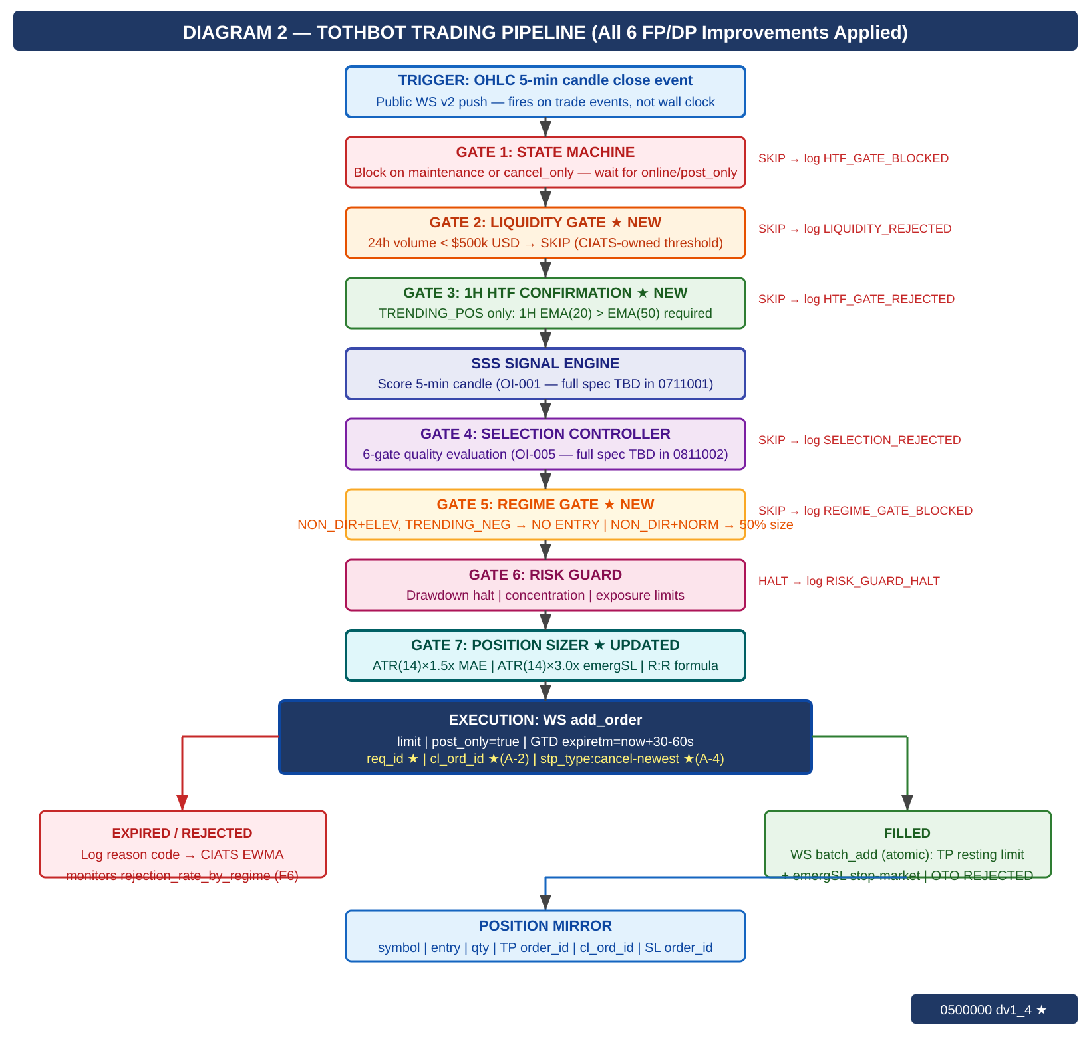

4. Exit Architecture — Ground Zero Redesign for Kraken
This exit architecture was rebuilt from zero for Kraken. It eliminates all competing exit strategies. The Exit Controller owns all normal exits. The Kraken off-book emergency SL stop order is crash protection only. OTO conditional orders were evaluated and rejected — batch_add on fill is confirmed correct (see AR-008).

4.1 Three-Layer Summary
Layer | Name | When It Fires
1a | Signal-Based Exit | Signal decay · time expiry · momentum loss. WS cancel TP + market sell.
1b | TP Fill | Resting TP limit on Kraken matching engine fills. EC cancels emergSL.
2 | MAE Threshold ★ | price-entry ≥ ATR(14)×1.5x. EC cancels TP+emergSL FIRST then market sell. ★ MPP RISK (C-1 dv1_4): market sell may reject on wide spread — Exit Controller MUST handle MPP rejection and retry. Assign: 0511004.
3 | Emergency Brake ★ | VPS/TothBot/internet failure ONLY. Off-book emergSL stop order at ATR(14)×3.0x on Kraken matching engine. NEVER in normal operation. ★ MPP RISK (C-1 dv1_4): triggered market order subject to MPP on wide spread. Assign: 0411001.

4.2 R:R Formula (Updated)
mae_pct = ATR(14) x 1.5x / entry_fill_price (CIATS-owned 1.5x multiplier, uses ACTUAL fill price)
net_loss = mae_pct + 0.16% + 0.26% (entry maker + MAE taker exit)
net_gain = net_loss x 1.5 (SACRED — hardcoded)
gross_target = net_gain + 0.16% (TP maker exit)
emergSL_dist = ATR(14) x 3.0x / entry_fill_price (NEVER in R:R formula — outside envelope)
NOTE: All calculations use actual fill price, not limit price. OTO conditional uses limit price — this is why OTO was rejected.

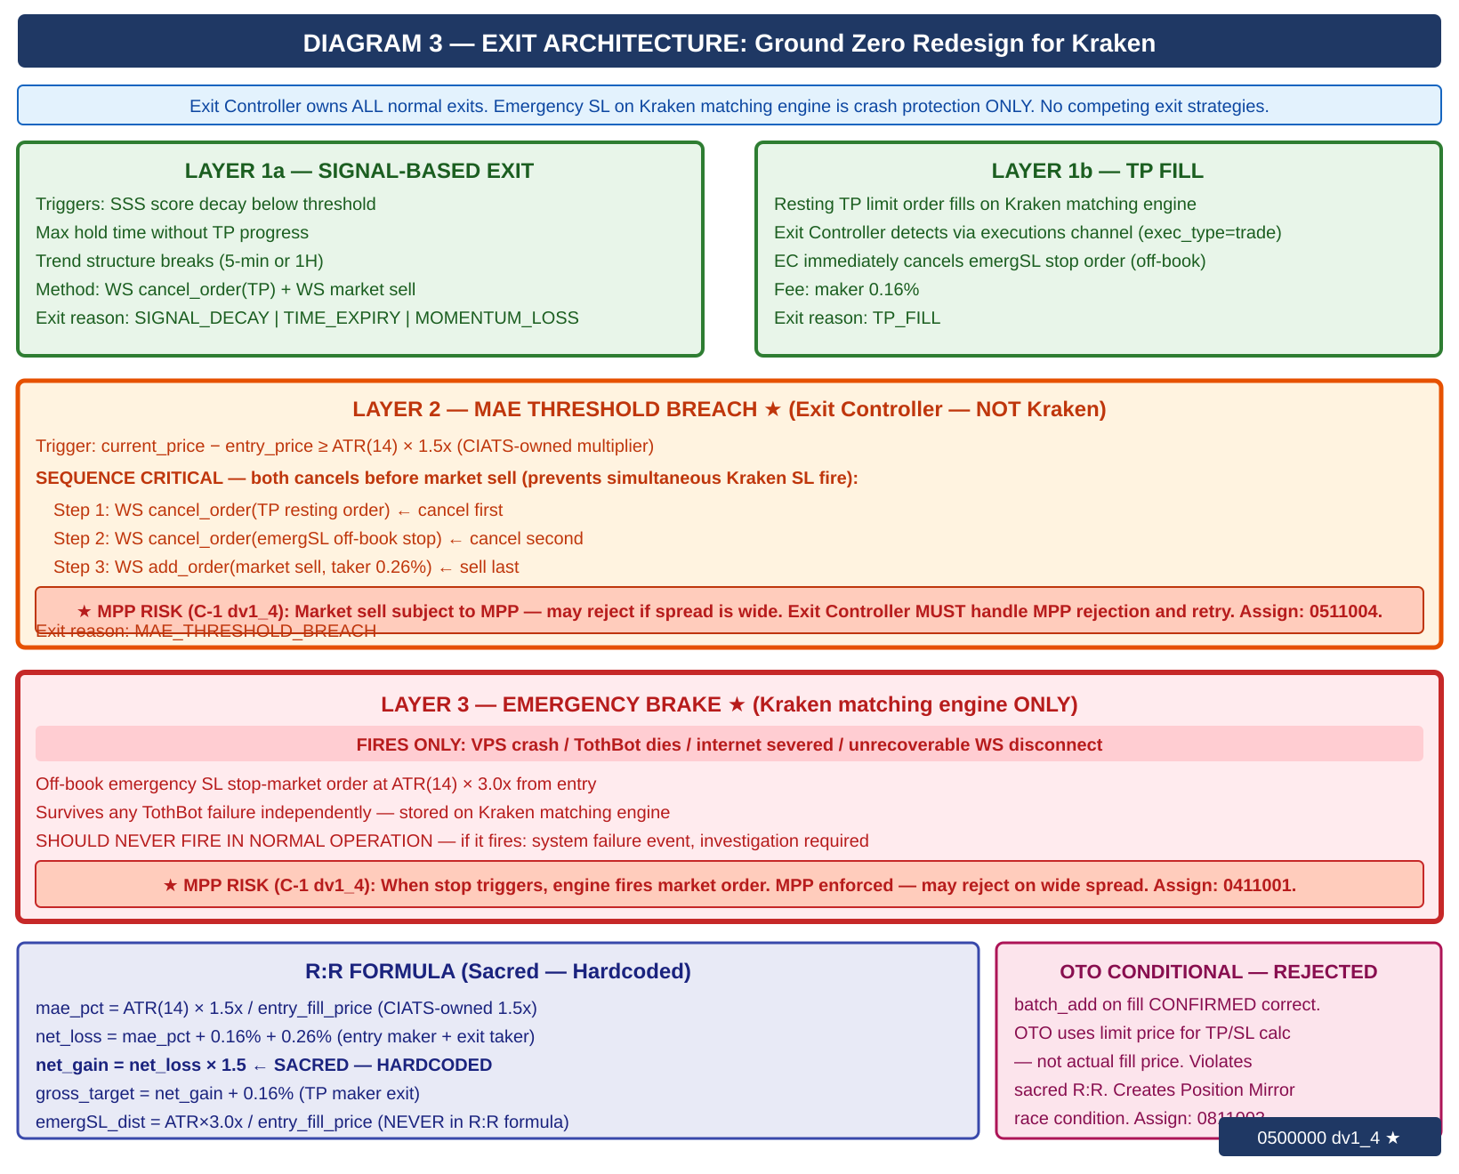

5. Regime Taxonomy
The six-regime grid is the foundation of CIATS regime-segmented analysis. Every trade is tagged with both asset_regime and market_regime (BTC proxy). Computed daily at 00:00 UTC.

5.1 Computation
Directional state: ADX(14) + EMA(20) vs EMA(50) on DAILY candles
Volatility state: ATR(14) percentile rank in 50-day rolling window

TRENDING_POSITIVE: ADX(14) > 25 AND EMA(20) > EMA(50)
TRENDING_NEGATIVE: ADX(14) > 25 AND EMA(20) < EMA(50)
NON_DIRECTIONAL: ADX(14) <= 25
NORMAL_VOL: ATR percentile <= 67th
ELEVATED_VOL: ATR percentile > 67th
asset_regime + market_regime (BTC/USD proxy) both tagged on every trade

ALL REGIME THRESHOLDS ARE CIATS-OWNED: ADX threshold 25, ATR percentile 67th, EMA periods 20/50, rolling window 50 days — all starting values. CIATS validates each after 600 closed trades (100+ per regime bucket).

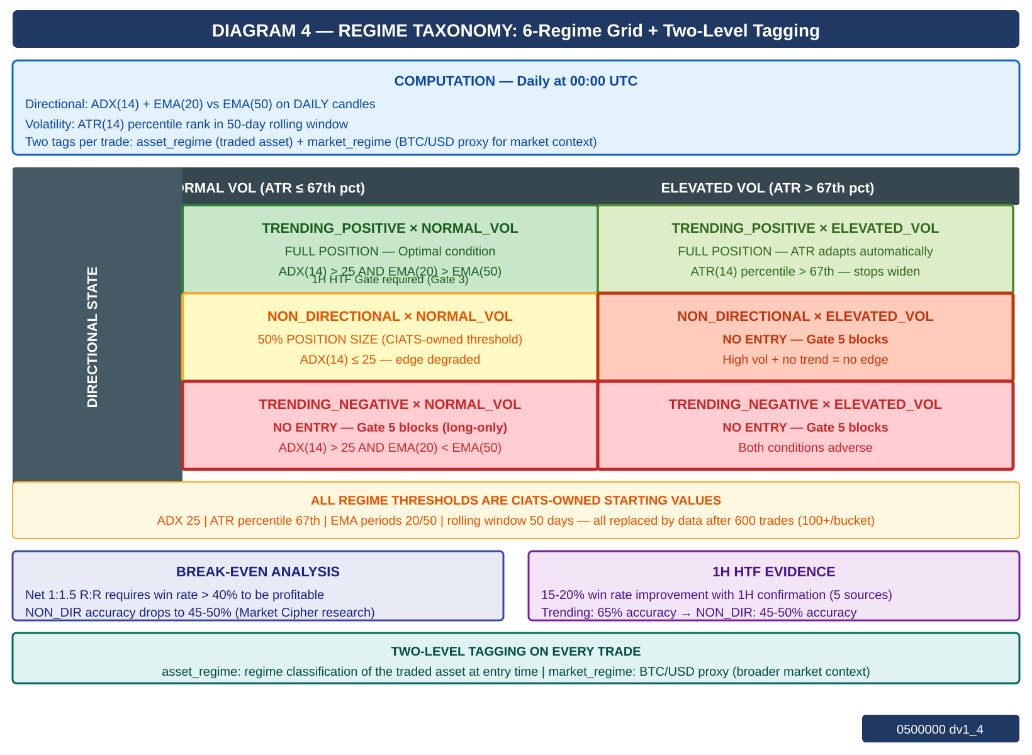

6. CIATS Architecture and Data Flows
CIATS is fully asynchronous. It never blocks the trading critical path. It reads only from the Logger and writes only to the Parameter Store. Deming PDCA governs every change.

6.1 Two Data Streams
Stream | Description
Stream 1: EWMA Monitor | 288 candle evals/day. Valid at 50 evals (~4 hrs). Detection within ~22 observations. Three monitoring signals: (1) post_only rejection_rate_by_regime (F6), (2) rate_counter_by_pair from executions channel (A-1), (3) ws_roundtrip_latency_ms from WS response timestamps (A-3). Monitoring signals ONLY — never drives parameter changes.
Stream 2: Trade Outcome Bus | Fires on each position close. Captures: symbol, entry/exit price, hold duration, MAE reached, fees, exit reason, both regime tags, signal params at entry, actual R:R, P/L.

6.2 Statistical Thresholds
Threshold | Purpose
50 candle evals | EWMA Monitor valid. Fast warning stream active. Monitoring only.
20 trades | CUSUM SPC trade-level. Sensitivity detection. Not for inference.
50 trades | Health check. Detect catastrophic misalignment only.
200 trades — HARD FLOOR | Inference valid. Proposal Engine activates. Half-Kelly replaces fixed 5%.
600 trades | Per-regime analysis: 100+ per bucket. Full regime-segmented optimization.
Rolling 200-300 | Current performance window — what the system is doing NOW.
Full corpus | Zero-cost historical library. Grows perpetually. Regime comparison.

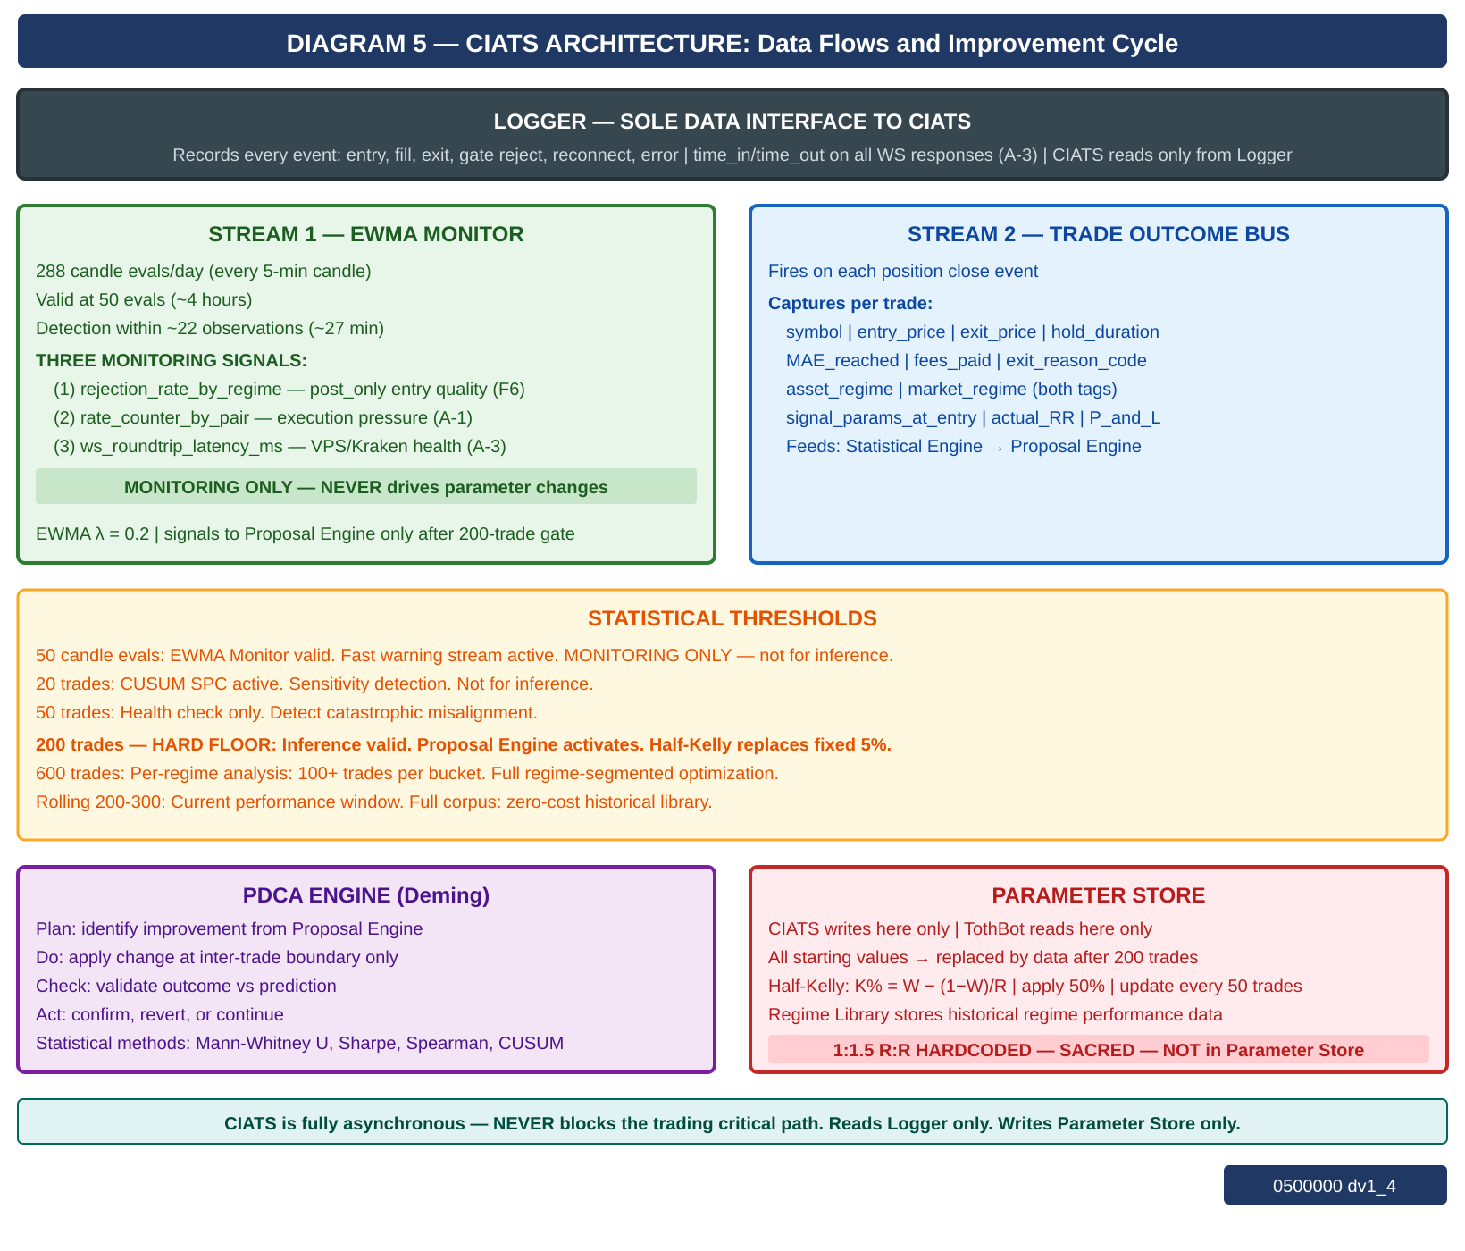

7. Complete System: One CIATS-Owned Organism
This diagram shows all three zones — Kraken, TothBot, and CIATS — as a single unified organism. Every flow and connection point is shown. ★ marks FP/DP validated additions.

CIATS OWNS EVERYTHING EXCEPT 1:1.5 R:R: All parameters, thresholds, sizing decisions, halt thresholds, multipliers, and trading rules are CIATS-owned starting values. They will be replaced by data-driven values during paper trading and live trading. By end of paper trading, all starting values will have been validated, corrected, or confirmed by real market data under Deming PDCA governance.

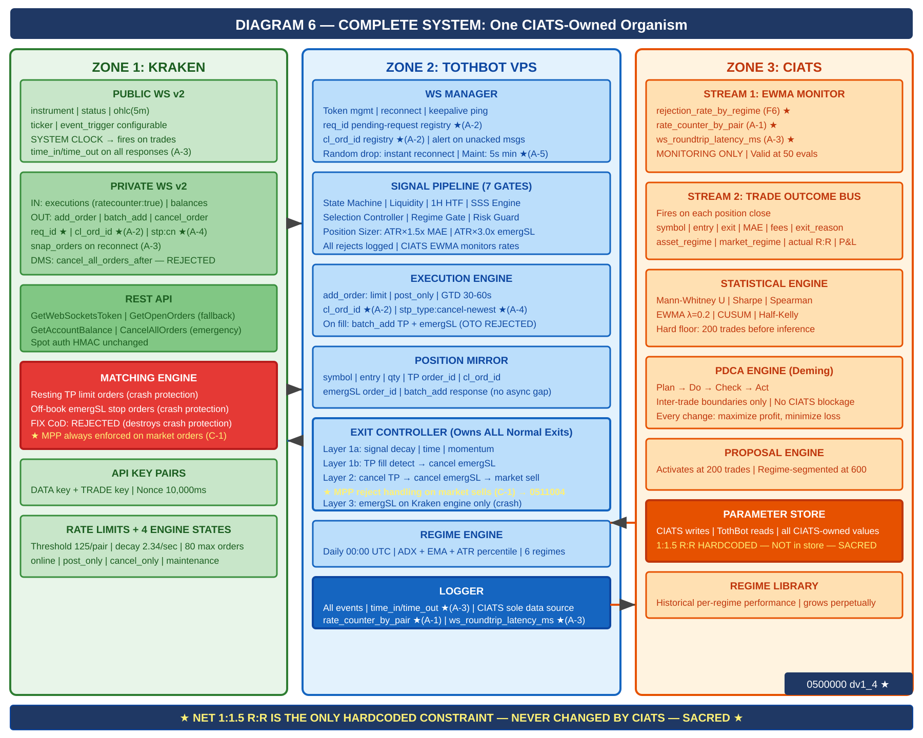

8. Locked Architectural Decisions
ID | Decision | Specification
AR-001 | No Dead Man Switch (DMS) | Resting TP limit orders and off-book emergency SL stop orders on Kraken matching engine ARE the crash protection. No separate DMS thread. EVALUATED AND REJECTED: (1) cancel_all_orders_after (WS v2 DMS) — would cancel ALL orders on TothBot failure including the protective off-book emergSL stop orders, leaving open positions with zero crash protection. (2) FIX API cancel-on-disconnect — same architectural conflict: FIX CoD cancels all orders on session drop, destroying the emergSL crash protection. Both evaluated and rejected: they defeat the crash protection mechanism they are supposed to support. The off-book emergSL IS the crash protection. It must survive any TothBot failure intact.
AR-002 | Position Mirror | Symbol, entry price, qty, TP order ID, cl_ord_id, SL order ID. Kraken-event-driven. cl_ord_id recorded at dispatch time before Kraken response — no async gap.
AR-003 | Restart reconciliation | PREFERRED: WS executions snap_orders:true on reconnect — provides all open orders over WS at zero REST call cost, available immediately on WS reconnect. FALLBACK: REST GetOpenOrders + GetAccountBalance — cold-start only or if snap fails. Verify emergSL orders — re-submit missing — then begin signals.
AR-004 | Two API key pairs | DATA key (market data) + TRADE key (orders + WS auth). Nonce window: 10,000ms on both.
AR-005 | WS v2 only | WS v1 not used. All future Kraken enhancements go into v2 only.
AR-006 | Entry order type | WS add_order: limit, post_only=true, GTD, expiretm=now+30-60s. cl_ord_id assigned by TothBot. stp_type:cancel-newest. CIATS-owned timeout.
AR-007 | TP placement | Resting limit via WS batch_add on entry fill. Actual fill price used for R:R calculation. Maker fee 0.16%.
AR-008 | Emergency SL placement | Stop-loss market via WS batch_add with TP in single atomic message. ATR(14)×3.0x from actual fill price. batch_add confirmed correct — OTO conditional evaluated and REJECTED: OTO uses limit price not actual fill price, violates sacred R:R; creates Position Mirror race condition between fill event and secondary order ID receipt.
AR-009 | Short deferred | Kraken Derivatives US CME futures. $1,000 below margin. Activates when conditions allow.
AR-010 | 24/7/365 | No stand-down. CIATS adds via PDCA only if data supports after 200 trades.
AR-011 | Net 1:1.5 R:R — SACRED | Only hardcoded constraint. Dynamic formula using actual fill price. NEVER changed by CIATS.
AR-012 | Fee baseline | Maker 0.16% / Taker 0.26%. CIATS monitors actuals.
AR-013 | Kraken Pro — Intermediate | Confirmed sufficient for all required API permissions.

9. Complete CIATS Parameter Registry
ALL PARAMETERS ARE CIATS-OWNED STARTING VALUES: CIATS owns all parameters after 200-trade gate. No ceilings. No required safety reviews for sizing changes. Deming PDCA governs every change. 1:1.5 R:R net is the only exception.

Parameter | Starting Value | CIATS Changes When...
tradeable_pct | 50% of portfolio | Drawdown analysis shows over/under-exposure.
per_trade_pct | 5% → Half-Kelly at 200 trades | Kelly criterion diverges. Updates every 50 trades thereafter.
max_concurrent | 20 positions | Concentration data shows optimal concurrency.
mae_mult (ATR×) | 1.5× ATR(14) | Actual MAE distribution clusters above/below. Mann-Whitney.
emergency_sl_mult | 3.0× ATR(14) | Ratio to MAE must remain ≥2×. Tail event distribution.
entry_timeout_sec | 30-60s GTD | Skip rate analysis vs fill opportunity. Spearman.
full_halt_drawdown | 10% of portfolio | Portfolio volatility distribution analysis.
session_pause_drawdown | 5% of portfolio | Session loss distribution. Mann-Whitney.
signal_thresholds | SSS gates (derived) | Signal cohort win rates diverge. Mann-Whitney.
adx_threshold | 25 | Regime classification accuracy vs trade outcomes.
atr_percentile_threshold | 67th | Vol regime accuracy vs outcome distribution.
htf_ema_periods | 20/50 daily | 1H HTF gate rejection vs signal quality outcomes.
min_volume_usd_daily | $500k USD | Post_only fill rate and SL quality vs volume floor.
1:1.5 R:R net | HARDCODED — SACRED | NOT CIATS-OWNED. The only permanent constraint in the system.

10. Six FP/DP Validated System Improvements
Derived from 80+ sources across 3 independent research passes plus second validation session. 5+ sources per parameter. Nothing added without data. Nothing changed without justification.

Finding 1: 1H HTF Confirmation Gate [TothBot]
Gap: | No layer between daily regime and 5-min entry.
Evidence: | 15-20% higher win rates with daily+hourly filter (5 independent sources 2024-2025).
Change: | Require 1H EMA(20)>EMA(50) for TRENDING_POSITIVE entries. Skip logged as HTF_GATE_REJECTED.
Effect: | Removes false signals during 1H pullbacks within daily uptrends. Zero API cost.

Finding 2: ATR Dynamic Stop Distances [TothBot/Exit]
Gap: | Fixed 2% stop ignores real-time market volatility.
Evidence: | +15% performance, -22% max drawdown vs fixed stops (LuxAlgo backtesting + 4 other sources).
Change: | MAE: ATR(14)×1.5x. Emergency SL: ATR(14)×3.0x. Both CIATS-owned starting values.
Effect: | Stop adapts to conditions. R:R formula preserved. Exit Controller fires before emergency SL.

Finding 3: Regime Gate [TothBot]
Gap: | Long momentum system trading in absent-edge conditions.
Evidence: | Accuracy 65%→45-50% in NON_DIRECTIONAL (Market Cipher). Break-even 40% for 1:1.5 R:R.
Change: | NON_DIR+ELEV and TRENDING_NEG: no entry. NON_DIR+NORM: 50% size.
Effect: | Stops trading when documented edge is absent. Pure loss minimization.

Finding 4: Minimum Liquidity Gate [TothBot]
Gap: | No minimum 24h volume on asset selection.
Evidence: | $1M+/day minimum for clean execution (Coin Bureau + 4 sources 2024-2025).
Change: | Asset Registry adds min_24h_volume_usd $500k starting. Checked daily via ticker.
Effect: | Protects fee formula. Ensures clean post_only fills and SL execution.

Finding 5: CIATS Half-Kelly Pathway [CIATS]
Gap: | Fixed 5% sizing had no defined data-driven transition.
Evidence: | Half-Kelly: 75% optimal growth at 50% less drawdown (MacLean-Thorp-Ziemba + 4 sources).
Change: | At 200 trades: K%=W-(1-W)/R, apply 50%. Update every 50 trades. No ceilings.
Effect: | Data-driven sizing replaces arbitrary fixed fraction after sufficient data.

Finding 6: post_only Rejection Monitoring [CIATS]
Gap: | Rejection events logged but unused by CIATS EWMA.
Evidence: | Rejection rate = direct signal of entry placement quality (Cube Exchange + 4 sources).
Change: | CIATS EWMA adds rejection_rate_by_regime stream. High rate in TRENDING = miscalibrated.
Effect: | Free diagnostic signal already in Logger. Entry optimization pathway activated.

11. Complete Trade Lifecycle — Narrative Reference

11.1 Normal Trade (Entry → TP or Exit Controller)
OHLC 5-min candle close fires on public WS v2
State Machine: online or post_only → continue; else halt and wait
Liquidity Gate: 24h volume ≥ $500k → continue; else skip
1H HTF Gate: 1H EMA(20) > EMA(50) for TRENDING_POS → continue; else skip
Signal Engine: SSS score computed on 5-min candle
Selection Controller: 6-gate quality evaluation → pass or reject
Regime Gate: TRENDING_POS: proceed; NON_DIR+NORM: 50% size; else block
Risk Guard: drawdown/concentration/exposure checks → pass or halt
Position Sizer: MAE = ATR×1.5x, emergSL = ATR×3.0x, TP = R:R formula
Execution: WS add_order (limit, post_only, GTD expiretm=now+30-60s, cl_ord_id assigned, stp_type:cancel-newest)
If expired/rejected: log reason code → CIATS EWMA monitors rejection rate. Done.
If filled: WS batch_add → TP (resting limit) + emergSL (stop-market) atomic. cl_ord_id recorded.
Position Mirror records: symbol, entry, qty, TP order_id, cl_ord_id, emergSL order_id
Exit Controller monitors. Logger records full entry with time_in/time_out. CIATS Trade Outcome Bus ready.
TP fills: EC cancels emergSL. Or EC fires Layer 1/2 exit. Position closes.
Logger records full exit. CIATS Trade Outcome Bus fires with complete trade record.

11.2 Layer 2 MAE Exit (Adverse Price)
Exit Controller detects: current_price - entry ≥ ATR(14) × 1.5x
WS cancel_order: cancel TP resting order
WS cancel_order: cancel emergSL stop order (off-book) ← SEQUENCE CRITICAL: both cancels before market sell
WS add_order: market sell (taker 0.26%)
★ MPP NOTE (C-1 dv1_4): Market sell subject to MPP enforcement. May reject if bid/ask spread is wide during adverse move. Exit Controller MUST handle MPP rejection and retry with adjusted limit price or IOC limit. Specification assigned to 0511004.
Logger: exit reason = MAE_THRESHOLD_BREACH
CIATS Trade Outcome Bus fires

11.3 Emergency SL (Layer 3 — System Failure Only)
VPS crashes / TothBot dies / internet severs / unrecoverable WS disconnect
Kraken matching engine fires off-book emergency SL stop-market order at ATR×3.0x
★ MPP NOTE (C-1 dv1_4): The triggered market order is subject to MPP enforcement. May reject on wide spread at time of trigger. Specification assigned to 0411001.
On restart: reconciliation detects closed position → Logger: EMERGENCY_SL_FIRED
This is a system failure event requiring investigation. Should NEVER fire in normal operation.

12. Open Items — Require Specification Documents
# | Item | Description
001 | Signal generation (SSS) | SSS scoring model re-derived from first principles for Kraken Spot.
002 | Asset selection universe | Kraken USDT/USDC pairs — eligibility criteria beyond liquidity gate.
003 | Exit Controller spec | Complete: signal decay thresholds, time exit rules, momentum detection, full L1/L2 decision tree. MPP rejection handling required (C-1 dv1_4).
004 | Entry limit placement | Exact rule for post_only limit price relative to bid/ask spread. Evaluate ticker event_trigger:bbo during derivation.
005 | Selection Controller | 6-gate formal specification.
006 | CIATS specification | Full spec: all interfaces, methods, PDCA workflows, regime library format.
007 | AA=04 Exchange Interface | Formal controlled document incorporating all decisions in this overview.
008 | All AA=10 coding specs | Full coding specs for every module, infrastructure component, and test suite.

13. Revision History
Version | Date | Description
dv1_0 | 03-23-2026 | Initial document. All architectural decisions, FP/DP improvements, exit architecture ground zero redesign, regime taxonomy, CIATS ownership model, and complete system flow.
dv1_1 | 03-23-2026 | Added all six system flow diagrams: (1) Kraken API connections, (2) trading pipeline with all gates, (3) exit architecture three layers, (4) regime taxonomy grid, (5) CIATS data flows, (6) complete one-organism system.
dv1_2 | 03-24-2026 | Six changes from deep API validation search. (C-1) Emergency SL terminology corrected throughout. (C-2) Intermediate tier rate limits added in new Section 2.3. (C-3) OHLC fires on trade events not wall clock. (A-1) ratecounter:true on executions. (A-2) req_id mandatory on all outbound WS messages. (A-3) time_in/time_out WS response latency logging. Open item 008 AA=11 corrected to AA=10.
dv1_3 | 03-24-2026 | Rebuilt as correct .docx with all six diagrams embedded. dv1_2 was produced in error without diagrams. All dv1_2 text changes present and correct. Diagrams recreated from SVG source files.
dv1_4 | 03-24-2026 | Seven changes from second deep API validation search (10 searches, 77+ sources). (C-1) MPP always enforced on market orders — no override. Risk noted for Layer 2 market sell (assign to 0511004) and Layer 3 emergSL trigger (assign to 0411001). (A-1) AR-001 expanded: explicit documented rejection of cancel_all_orders_after (DMS) and FIX cancel-on-disconnect — both destroy crash protection. (A-2) cl_ord_id added to all outbound WS messages; Position Mirror updated to record at dispatch time. (A-3) WS executions snap_orders:true as preferred restart reconciliation path; REST remains fallback. AR-003 updated. (A-4) stp_type:cancel-newest on all add_order and batch_add calls. (A-5) Reconnect constraint distinction: random drop = instant reconnect; maintenance = 5s minimum delay. (A-6) OTO conditional orders evaluated and REJECTED — batch_add confirmed correct (actual fill price required for sacred R:R; eliminates Position Mirror race condition). All six flow diagrams updated to reflect dv1_4 changes.

